LAB 2

QUESTION 01 (CODE)

import java.lang.String;

public class task1

{

public static void main(String str [])

{

String str1="Ghulam";

String str2="Mustafa";

System.out.println(str1.concat(str2));

}

}

**OUTPUT**

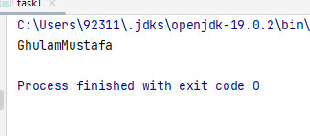

QUESTION 02 (CODE)

import java.util.Scanner;

public class task2

{

public static void main( String args[])

{

System.out.println("Write your full name:");

Scanner input=new Scanner(System.in);

String fullName=input.nextLine();

System.out.println("Initial letter are "+fullName.charAt(0));

for(int i=0; i<fullName.length(); i++)

{

if(fullName.charAt(i)==' ')

{

System.out.println(fullName.charAt(i+1));

}

}

}

}

**OUTPUT**

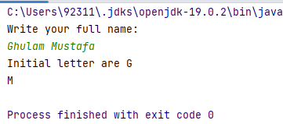

QUESTION 03 (CODE)

public class task3 {

public static void main(String[] args) {

String str="The quick brown fox jumps over the lazy dog";

System.out.println(str.replace("fox","cat"));

}

}

**OUTPUT**

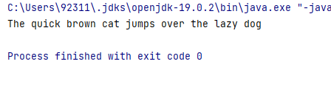

QUESTION 04 (CODE)

public class task4 {

public static void main(String args[])

{

for(int i=0; i<200; i++)

{

int ct=0;

for(int k=1; k<=i; k++) {

if (i % k == 0) {

ct++;

}

}

if(ct==2)

{

System.out.print(i+” “);

}

}

}

}

**OUTPUT**



QUESTION 05 (CODE)

import java.util.Scanner;

public class task5 {

public static void main(String args [])

{

Scanner input=new Scanner(System.in);

System.out.println("Write the value of a:");

double a=input.nextDouble();

System.out.println("Write the value of b:");

double b=input.nextDouble();

System.out.println("Write the value of c:");

double c=input.nextDouble();

double x1=-b+(Math.sqrt(Math.abs(b*b-(4*a*c))))/(2*a);

System.out.println("The first value of x is="+x1);

double x2=-b-(Math.sqrt(Math.abs(b*b-(4*a*c))))/(2*a);

System.out.println("The second value of x is="+x2);

}

}

**OUTPUT**

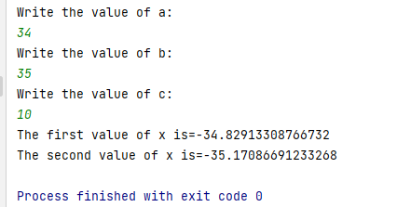

QUESTION 06 (CODE)

import java.util.Scanner;

class task6{

public static void main(String[] args)

{

int n=1;

int x=30;

int odds[]=new int [x];

for(int i=0; i<x; i++)

{

odds[i]=n;

n=n+2;

}

System.*out*.println("Odd values are ");

for(int i=0; i<15; i++)

{

System.*out*.print(odds[i]+" ");

}

}

}

**OUTPUT**

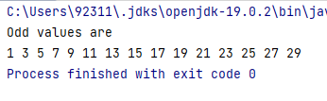

QUESTION 07 (CODE)

import java.util.Scanner;

class task7{

    public static void main(String[] args) {

    Scanner input=new Scanner(System.in);

     System.out.println("Enter first number:");

    double num1=input.nextDouble();

    System.out.println("Enter second number:");

    double num2=input.nextDouble();

    double Result=num1/num2;

    int myInt=(int) Result;

    if(Result-myInt>=0.5)

    {

        myInt++;

        System.out.println("Result="+myInt);

    }

    else

    {

        System.out.println("Result="+myInt);

    }

    }

}

**OUTPUT**

